\ shift+1 clear // to clear the sql screen

psql -U postgres //connect from git bash

\list //to see the info inside database

\c databasename //to connect inside any database or table

\du //will provide list of roles and permition

\dt //will show list of table

What is schema: insise a database there is many database, those calles schema. It could be public or private

CREATE ROLE b2001user; //Create users in postgrace :

\du //to see created or not

CREATE ROLE b2002user2 WITH LOGIN SUPERUSER CREATEDB CONNECTION LIMI

T-1 PASSWORD 'b2002user2'; //to create ROLE WITH LOGIN POWER

\c postgres user2 //to login to a user

\c postgres postgres

ALTER USER user2 RENAME TO user1 // to rename user.

From cmd: to restore the dvdrental

C:\Users\Fatema Akter>pg_restore -U postgres -d dvdrental "C:\Users\Fatema Akter\Downloads\dvdrental.tar"

DROP DATABASE databasename;

DROP ROLE b2002user; //DROP ROLE

Create database mydb;

\c mydb

CREATE TABLE mytable1 (id integer, name varchar(20));

CREATE TABLE

\dt

INSERT INTO mytabe(id, name) valus (01, ‘ftma’);

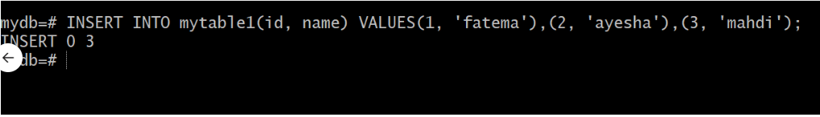

Select * from mytable;

Create schema [if not exist] myschema

\dn //see list of schema

INSERT INTO mysch mytabe(id, name) valus (01, ‘ftma’);

Clickon surver >create>postgrace>connection=localhost>